Tic-Tac-Total
AQA A-Level Computer Science NEA

Leo Thompson: 3986
Harington School: 24345
Contents

Section A: Analysis
Context Of Problem
Mathematics is a compulsory subject within all educational institutions in the United Kingdom up to the age of 16, where students are required to complete General Certificate of Secondary Education (GCSE) examinations. As a core component of STEM (Science, Technology, Engineering, and Mathematics), it plays a critical role in both academic progression and everyday life. Mathematical skills are essential for practical tasks such as budgeting finances, interpreting data, measuring quantities, and solving real-life problems. Mathematics is assessed through a range of examination boards, each with differing structures and assessment styles.
Nationally, approximately 32% of students fail mathematics examinations each year across GCSE and A-Level qualifications, highlighting a significant and persistent issue within mathematics education. A key contributing factor is the difficulty many students experience in keeping pace with lessons, which can lead to disengagement and reduced confidence over time. At A-Level, students commonly struggle with complex topics such as integration and differentiation, which require both accuracy and strong procedural knowledge. At GCSE level, students frequently encounter difficulties in algebraic manipulation, problem-solving, and interpreting worded questions.

This issue can be further understood through specific institutional data. Harington School, a relatively small sixth form centre with approximately 300 students, offers both Mathematics and Further Mathematics at A-Level under the Pearson Edexcel specification. In 2025, the average mathematics grade achieved was a B, and 82.2% of all grades across the school were at grade C or above. While this indicates generally strong academic performance, it also suggests that a proportion of students are not achieving the highest grades, particularly in more demanding areas of the subject.

In contrast, Stamford Welland Academy, with approximately 600 students aged 11–16, demonstrates more significant challenges at GCSE level. In 2025, only 18.1% of students achieved a Grade 5 or above in both Mathematics and English, which is substantially below the local authority average of 41.9%. This indicates a clear attainment gap and suggests that many students struggle to meet expected standards. The school has implemented interventions such as “Session 6,” an after-school support programme designed to improve attainment; however, the available data suggests that its impact has been limited.
Overall, both institutions demonstrate that, despite differing levels of attainment, mathematics remains a challenging subject for many students. The combination of national statistics and local performance data highlights the need for more effective and engaging methods to support students in developing their mathematical skills.

Analysis of Problem
Mathematics, as a core subject, is expected to be understood at a fundamental level by all students; however, a range of systemic, psychological, and educational challenges prevent this from being achieved. One significant structural issue is the requirement for students who fail mathematics to resit examinations. This can create a cycle of repeated failure, often referred to as a “resit crisis,” where students are required to retake the same assessments without sufficient variation in approach or support, leading to further disengagement.
Psychological factors also play a major role in hindering mathematical performance. Many students experience high levels of anxiety when approaching mathematics, often due to pressure to produce correct answers within limited time constraints. This can negatively impact performance, particularly in exam situations where time efficiency is essential. Additionally, repeated difficulty can lead to a loss of confidence, causing students to disengage and avoid practising mathematics altogether.
Educational approaches further contribute to the problem. Traditional teaching methods often rely heavily on repetitive practice and standardised question formats, which may not sustain student engagement over time. In addition, modern classroom practices can sometimes involve students passively copying notes from a screen or presentation, which limits active participation and reduces opportunities for deeper engagement with the content. As a result, students may struggle to remain motivated, particularly when working independently outside of lessons. Furthermore, many students find it difficult to effectively revise mathematics in their own time, as existing methods may lack interactivity or immediate feedback.
A common challenge is the difficulty students face with worded problems, which require them to interpret information and apply appropriate methods under time pressure. This highlights the importance of not only practising mathematical techniques but also developing the ability to apply them efficiently in exam-style conditions.
Overall, these issues demonstrate a need for a more engaging and accessible approach to mathematics practice—one that supports independent learning, reinforces skills through active participation, and helps students improve both confidence and performance under timed conditions.

Interview
To better understand the needs of the intended users and ensure the proposed solution is appropriate, interviews were conducted with two students: one studying Mathematics at A-Level and one studying Mathematics at GCSE. These interviews aimed to identify common difficulties, attitudes towards mathematics, and preferences for revision methods. The findings will be used to inform the key features and design of the solution.
Interview 1: A-Level Mathematics Student
The first interview was conducted with an A-Level Mathematics student currently studying under the Pearson Edexcel specification. This student has prior experience of GCSE mathematics and is familiar with the increased difficulty and expectations at A-Level.
Q1: How do you find A-Level Mathematics compared to GCSE?
A: It is quite a big step up. At GCSE, you can often follow methods quite easily, but at A-Level you actually need to understand why things work rather than just memorising them. If you don’t properly understand a topic, it becomes very difficult to answer unfamiliar questions.
Q2: Which areas of mathematics do you find most challenging?
A: Integration and differentiation, mainly because there are lots of different techniques. It’s easy to forget small steps or apply the wrong method, especially if you haven’t practised regularly.
Q3: How do you currently revise mathematics?
A: I mostly use past papers and textbook questions. Sometimes I go over my notes, but I don’t always find that helpful unless I already understand the topic.
Q4: Do you find this method effective?
A: It works to an extent, but it gets very repetitive. After a while, it feels like I’m just doing the same type of questions over and over again without really improving much. It can also be quite boring, so I don’t always stay focused for long periods of time.
Q5: How confident do you feel when answering questions under timed conditions?
A: Not very confident. In class I can usually complete questions, but in exams I feel rushed and more likely to make mistakes, especially on longer questions.
Q6: What do you think causes this lack of confidence?
A: Probably a combination of not practising enough under time pressure and not always being fully secure on the methods. Most of the time we practise questions straight after learning the topic, rather than coming back to them later in a timed fashion.
Q7: Do you enjoy learning mathematics? Why or why not?
A: Sometimes, especially when I understand the topic and can answer questions correctly. But when I struggle, it becomes frustrating quite quickly. Lessons can also feel repetitive at times, which makes it harder to stay motivated.
Q8: Would a more interactive or game-based approach to revision help you?
A: Yes, definitely. I think it would make revision more engaging and less of a chore. If it felt more like a game, I would probably be more likely to use it regularly.
Q9: What features would you like in a revision tool?
A: Quick-fire questions, something that tracks progress over time, and possibly a competitive element, like playing against someone else or trying to beat a score. That would make it more interesting.
Q10: Would timed challenges or competition improve your exam performance?
A: Yes, because it would help me get used to working under pressure. Competing against someone else or trying to beat a score or timer would probably push me to think faster, and over time I would become both quicker and more accurate when answering questions.
Interview 2: GCSE Mathematics Student
The second interview was conducted with a GCSE Mathematics student studying under the AQA specification. This student represents a younger user group who may still be developing both confidence and core mathematical skills.
Q1: How do you find mathematics as a subject?
A: It’s quite difficult. Sometimes I understand it in class, but when I try questions on my own, I get stuck quite quickly and don’t always know what to do next.
Q2: What topics do you struggle with most?
A: Algebra, especially because it comes up a lot in higher-level questions. I also struggle with worded questions because I don’t always understand what the question is asking me to do.
Q3: What usually happens when you don’t understand a topic in class?
A: I tend to fall behind, and then it becomes harder to keep up with the next lessons because they build on what we’ve already learned. After that, I just lose confidence.
Q4: How do you revise mathematics outside of lessons?
A: I don’t really revise it much unless I have homework or a test coming up. When I do revise, it’s usually just answering questions from a worksheet or textbook.
Q5: Why do you not revise it regularly?
A: Mainly because it feels boring, and I’m not always sure what I should be revising or where to start. I also find it harder to stay focused when I’m working on my own, and sometimes it just feels pointless, like you either understand maths or you don’t.
Q6: Do you ever revise with other people?
A: Not usually, but I think it would help. If I was revising with someone else or competing against them, I would probably be more motivated to actually do it.
Q7: Do you find lessons engaging?
A: Sometimes, but quite often it’s just copying notes from the board or doing similar questions, which can get repetitive after a while and doesn’t really help me stay interested.
Q8: Would you be more likely to revise if it was more interactive or game-based?
A: Yes, definitely. If it was more like a game or something competitive, I would be much more willing to revise. It would make it feel less like work and more enjoyable.
Q9: Would instant feedback on answers help you?
A: Yes, because then I would know straight away if I got something wrong and could try again. At the moment, I sometimes don’t find out until later, which isn’t as helpful.
From these interviews, several key themes have emerged. Both students identified a lack of engagement as a major issue when revising mathematics, with traditional methods such as completing past papers or copying notes often described as repetitive and unmotivating. This indicates that any effective solution should incorporate interactive elements that encourage active participation, rather than passive learning, in order to maintain user interest over time.
In addition, both students highlighted a lack of confidence, particularly when working under timed conditions or when revisiting more complex topics. This suggests that a suitable solution should provide opportunities for practising mathematics in a way that reflects exam-style pressure, allowing users to gradually build both speed and accuracy in a low-risk environment.
Another important finding is that students struggle to maintain motivation when revising independently, particularly outside of structured lesson time. However, both students indicated that incorporating competition or working alongside others would make revision more engaging. This demonstrates the need for a solution that can be accessed easily outside of school, college, or sixth form, while also encouraging competitive interaction to increase motivation and sustain engagement.
Furthermore, both students expressed a clear preference for a more engaging and interactive approach, with specific interest in game-based and competitive elements. This suggests that incorporating features such as progression tracking and competitive gameplay could encourage more consistent use and increase motivation to practise regularly.
Finally, the importance of immediate feedback was highlighted, particularly by the GCSE student. This indicates that users benefit from being able to quickly identify and learn from mistakes, reinforcing understanding more effectively than delayed feedback.
It can therefore be concluded that any solution to this problem would need to be interactive, engaging, and easily accessible beyond the classroom environment. It should support consistent practice through competitive gameplay, provide timed questions to reflect exam conditions, and include immediate feedback to reinforce learning and improve overall performance.

Existing Systems
Tic Tac Toe Math – RoomRecess.com
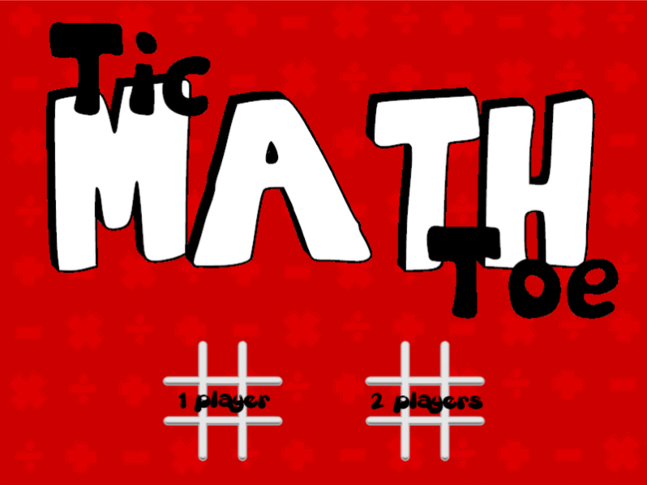
Two-player mode encourages competition and make revision more engaging

The current player is always clearly displayed. This is important in a two-player system, as it prevents confusion and allows gameplay to flow smoothly.
The game could be played with another player, acting as a “study buddy”. This supports collaborative revision and may encourage more regular use outside of lessons.

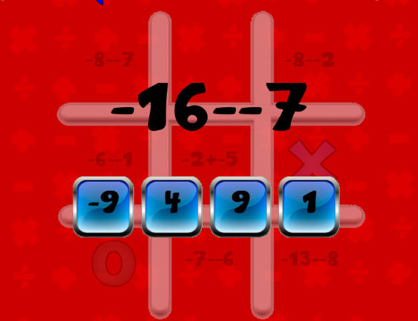
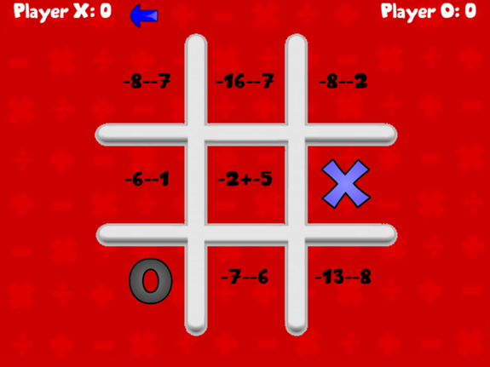

A symbol is only placed in the grid if the question is answered correctly. If the answer is incorrect, the player loses their turn. This links success in the game directly to mathematical ability.
When a grid square is selected, the question appears in an enlarged state. This immediately draws the user’s attention to the question and makes and makes it clear that the answer must be completed before the move can be made.
Questions are presented as multiple choice. Although this make the game easier to use, it also reduced challenge because players can guess that answer.

The game uses simple visual feedback by immediately showing the symbol in the chosen grid cell after a correct answer. While this makes the result of each question clear to the user, a correct answer isn’t provided if a wrong answer is given, restricting development of improvement in mathematical ability.
The game records simple statistics, such as number of wins for each player. This is useful because it creates a stronger sense of competition and encourages players to continue using the program.



MathsBuster
Each question clearly states the topic being tested. This allows the user to identify which areas of mathematics they are confident in and which topics require further practice.
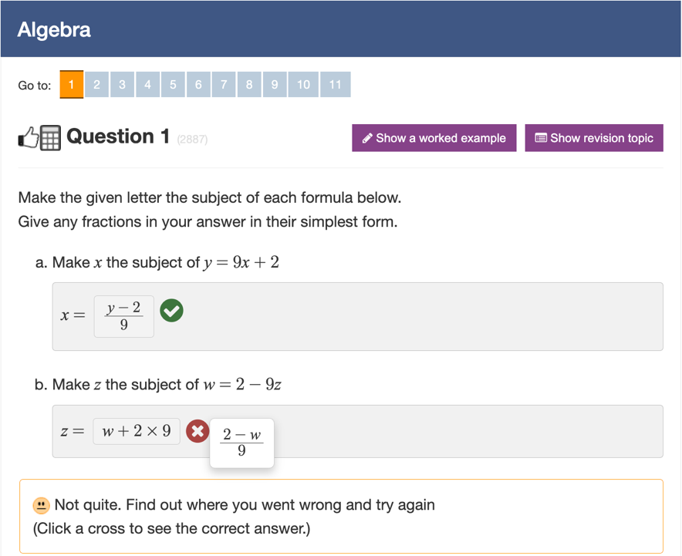

The system gives instant feedback after every answer by clearly indicating whether the response was correct or incorrect. This is important because delayed feedback makes it harder for users to learn from mistakes.

If an answer is incorrect, the correct answer is shown. This is a useful feature because it allows the user to understand their mistake immediately and improve before attempting another question.

The interface is clear and simple, with large buttons and clearly separated question areas. This reduces confusion and ensures that the user can focus on answering the question and improving their mathematical ability rather than navigating the program.

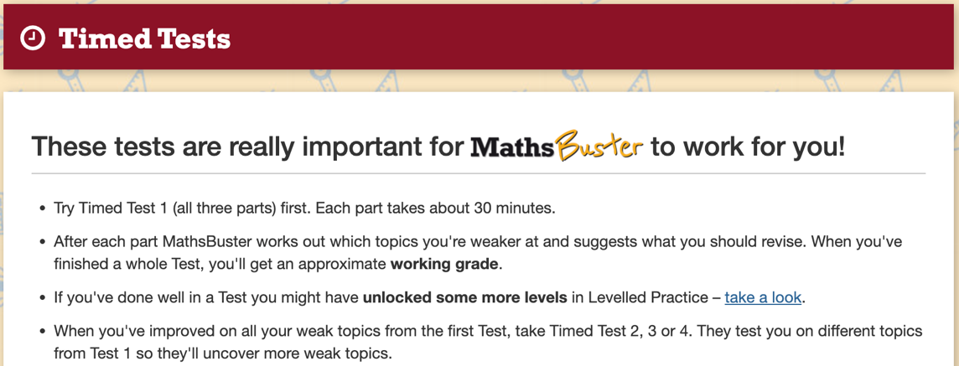
The system includes a dedicated timed practice section. This is particularly useful because timed exam conditions is commonly identified as a major difficulty.

Identification of Users
The intended users of this system are GCSE and A-Level Mathematics students, typically aged between 14 and 18, with a range of abilities. The system is targeted towards, but not limited to, students who lack confidence, struggle with engagement, or find traditional revision methods repetitive and ineffective, as well as those aiming to improve their overall performance in mathematics. The system also targets the large proportion of candidates who find timed exam conditions challenging. As a result, it must incorporate timed questions to improve both speed and accuracy in a controlled and low-pressure environment, as well as interactive elements specifically designed to increase engagement and encourage consistent use, without overwhelming the user.
In terms of technical ability, users of this age group are generally familiar with digital devices and common interface elements such as menus and buttons. However, the system must remain intuitive and easy to navigate so that users can focus on answering questions rather than learning how to use the program. This means the interface should be clear, responsive, and require minimal instruction.
The system will be used on personal devices such as laptops or desktop computers, both in school and at home. As it is not intended for use on large display screens such as teacher interactive whiteboards, interface elements such as text, buttons, and interactive components (e.g. sliders and dialogue pop-ups) should be appropriately sized for individual screens, ensuring clarity and ease of interaction without requiring excessive scaling.
Additionally, the system is intended for two-player use, meaning that interaction between users is a key component. Therefore, the design must clearly display game states, player turns, and outcomes in an easily understandable way to avoid confusion during gameplay. Visual clarity is particularly important to ensure that both players can quickly interpret the current state of the game and respond accordingly.
Finally, given that users may have differing levels of mathematical confidence, the system must also accommodate a range of abilities. This can be achieved through clear question presentation, appropriate difficulty selection (GCSE or A-Level), and immediate feedback to support learning. The inclusion of timed elements must also be carefully balanced to provide challenge without overwhelming the user, ensuring that it supports improvement rather than discouraging participation.

Requirements
From the interviews
The interviews showed that students find traditional methods of mathematics revision, such as copying notes or completing textbook questions, repetitive and unengaging. Therefore, the solution should be interactive and game-based in order to maintain interest and encourage regular use.
Both students stated that they would be more motivated if they could revise with or against another person. As a result, the program should include a competitive two-player element so that users can revise with a “study buddy” while still making revision more enjoyable.
The interviews also highlighted that timed exam conditions are a major difficulty. Therefore, the system should include timed questions to help users improve both speed and accuracy in a lower-pressure environment.
Students identified several mathematical topics that they commonly find difficult, including algebra, differentiation, integration, and interpreting worded questions. The system should therefore include questions from a range of mathematical topics and difficulty levels so that it is useful to both GCSE and A-Level students.
Finally, both interviewees emphasised the importance of instant feedback. The program should immediately indicate whether an answer is correct or incorrect and, where appropriate, display the correct answer so that users can learn from mistakes straight away.

From Existing Solutions
The analysis of existing systems showed that features such as clear turn indicators, question pop-ups, and statistics tracking are effective and should be included within the final solution.
Existing systems also demonstrated the value of linking mathematical success directly to game progression. Therefore, a player should only be able to make a move if they answer a question correctly.
However, the existing systems often become repetitive or too easy, particularly when they rely on multiple-choice questions. To improve upon this, the final solution should require users to enter their own answer and should include an element of randomness or unpredictability to keep the game engaging over time.

From Identification of Users
The identification of users showed that the program will be used by GCSE and A-Level students with varying levels of mathematical confidence. Therefore, the interface must be simple, clear, and easy to navigate so that users can focus on answering questions rather than learning how to use the program.
As the system will be used on personal devices such as laptops and desktop computers, text, buttons, and other interface elements should be appropriately sized for smaller screens rather than large classroom whiteboards.
The identification of users also showed that the system must be accessible outside of school or sixth form. Therefore, it should be quick to access, require minimal setup, and be suitable for use at home or elsewhere.

Acceptable Limitations
A number of acceptable limitations have been identified for the system in order to keep the project realistic and achievable within the available development time.
The system will not include an AI opponent or network multiplayer functionality. Gameplay will instead be limited to two players using the same device. This is acceptable because the primary aim of the system is to support revision through local, turn-based interaction rather than to create a complex online game.
Only two difficulty levels will be provided: GCSE and A-Level. Although this does not account for finer distinctions in ability, it is sufficient because these categories match the intended target audience and provide a clear separation between the two main stages of study. Content beyond A-Level standard will not be included, as the system is being developed at A-Level standard; therefore, it would not be realistic to design and verify questions at a higher level accurately.
The system will be unable to generate completely dynamic questions, including entirely new phrasing or question styles. Instead, the question generator will be limited to a fixed set of pre-defined templates. Although the numerical values within each question will vary, the system will only use a small number of question structures at each level. This means that experienced users may begin to recognise the types of questions that can appear. Similar question types may also appear more than once in a session. This limitation is acceptable because a more advanced system capable of generating new question structures dynamically would be significantly more complex.
The system will only accept integer and short string answers in specific pre-defined formats. Equivalent answers written in a different way, such as “6.0” instead of “6”, will not be accepted unless they have been explicitly included as valid alternatives. As a result, question types requiring more complex answers, such as trigonometric expressions, surds, or unsimplified fractions, cannot be used. This is acceptable because restricting answers to simple formats makes answer checking more reliable and realistic to implement within the scope of the project.
There will also be some limitations on the game functionality. The grid size will be capped at 10 × 10, and the bomb density will remain fixed. This prevents the game from becoming excessively large or unbalanced, while still allowing enough variation to maintain challenge and engagement.

Success Criteria
QUALITATIVE CRITERIA
- The game must be easy to pick up and play without reading any documentation — a new player must be able to understand what to do from the starting dialogs alone.
- The correct-answer and incorrect-answer visual feedback must be immediately clear to both players without any explanation.
- The bomb mechanic must feel tense and exciting; the countdown timer and explosion animation must create a genuine sense of urgency for the player trying to defuse it.
- The interface must look visually consistent throughout — fonts, colours, and layout must form a coherent style at every stage of the game.
- The difficulty levels must feel appropriately challenging — GCSE questions must be suitable for GCSE students and A-Level questions must be noticeably harder, appropriate for students studying A-Level Mathematics.
- The game must feel fair to both players; neither player must have a structural advantage due to their symbol, the layout of the grid, or the selection of questions.
- The statistics panel must be readable at a glance without obscuring or distracting from the game board.
- The bomb explosion animation must be visually impressive and must clearly communicate that tiles in the surrounding area have been cleared.
- The transition between rounds (after a win, draw, or reset) must feel immediate — there must be no noticeable lag or visual disruption when a new round begins.
- The answer-feedback flash must be long enough for both players to read the correct answer comfortably but short enough that it does not disrupt the pace of play.

QUANTITATIVE CRITERIA

Start-up and Configuration
- On launch, the program must display a difficulty-selection dialogue before the game board is shown.
- The difficulty-selection dialogue must offer exactly two options: "GCSE" and "A-Level".
- After difficulty selection, the program must present an input dialog asking for the name of Player 1, followed by a second dialog asking for the name of Player 2.
- If a player leaves their name field blank or cancels the dialogue, the program must automatically substitute the default name "Player 1" or "Player 2" respectively.
- The application window title must read "Tic-Tac-Total".

Layout
- The main window must contain five distinct regions: a header banner at the top, a statistics panel on the left, the game board in the centre, a Reset button at the bottom, and a grid-size slider on the right.
- The header label must display centred text in bold white font on a dark background.
- The Reset button must have a dark background and be clearly labelled “Reset”.
- The grid-size slider must be oriented vertically, positioned to the right of the game board.
- The statistics panel must be positioned to the left of the game board and must always be visible during play.

Game Board and Grid
- The game board must display a square grid of tiles, where every cell contains exactly one tile.
- The grid must support all sizes from 3×3 to 10×10 inclusive.
- The slider on the right of the window must allow the player to select any grid size between 3 and 10.
- When the grid-size slider is moved to a new value, the board must immediately reset and a new round must begin at the new grid size.
- The game must start with a default grid size of 3×3.
- Tile font sizes must scale dynamically with the current grid size so that symbols (X and O) remain clearly legible on all supported grid sizes.

Standard Tiles
- Empty standard tiles must appear as plain white buttons with no text.
- A claimed standard tile must display the claiming player's symbol (X or O) centred inside the tile.
- Clicking an already-occupied tile must have no effect on the game state.
- Clicking any tile while an animation is in progress (bomb explosion or answer flash) must have no effect.
- Clicking an empty standard tile must immediately present a maths question to the current player in a dialogue.
- If the player answers a standard-tile question correctly, their symbol must be placed in that tile and the tile must flash green for exactly 600 milliseconds.
- If the player answers a standard-tile question incorrectly, the tile must flash red for exactly 1,500 milliseconds, and during that flash the tile must display the correct answer.
- After an incorrect answer on a standard tile, the turn must pass to the other player once the red flash completes.
- After a correct answer on a standard tile, a win/draw check must be performed before the turn switches.

Maths Questions
- Standard questions at GCSE difficulty must be drawn randomly from at least the following topic types: linear equations, percentages, area of rectangles and triangles, mean of a dataset, powers and indices, algebraic substitution, and speed/distance/time.
- Standard questions at A-Level difficulty must be drawn randomly from at least the following topic types: differentiation (power rule), second derivatives, stationary points, definite integration, logarithms, binomial coefficients, and inverse-trigonometric angles.
- Each time a question is needed, a topic type must be selected at random, and the numerical parameters of that question (coefficients, dimensions, values, etc.) must be freshly generated at random — so that the specific numbers differ between questions even when the topic type repeats.
- Answer checking must be case-insensitive and must strip leading and trailing whitespace from the player's input before comparing it against the correct answer.
- Where a question has more than one valid way to express the correct answer (for example "0.5" and "1/2"), all accepted forms must be stored with the question and any one of them must be accepted as correct.

Bomb Tiles
- Bomb tiles must be hidden — before being clicked, a bomb tile must appear visually identical to an empty standard tile.
- Clicking a bomb tile must trigger the bomb: the tile must reveal its bomb graphic and begin an animated fuse-burn sequence.
- Simultaneously with the bomb animation beginning, a dedicated bomb-diffuse dialogue must be displayed, presenting the current player with a harder maths question.
- The bomb-diffuse dialogue must show the question, an answer input field, and a "DEFUSE!" submit button.
- The bomb-diffuse dialog must display a countdown timer starting at 35 seconds, with a visible progress bar that decreases as time passes.
- When 5 or fewer seconds remain on the countdown, the countdown label must change colour to red to warn the player.
- Bomb-diffuse questions at GCSE difficulty must be drawn from harder GCSE topics, covering at least: quadratic equations, Pythagoras' theorem, simultaneous equations, and nth-term sequences.
- Bomb-diffuse questions at A-Level difficulty must be drawn from harder A-Level topics, covering at least: geometric series sums, chain-rule differentiation, and harder definite integrals.
- If the player answers the bomb-diffuse question correctly within the time limit, the bomb must be diffused: the bomb tile must convert to an empty standard tile and the player's symbol must be placed in that cell.
- After a successful diffuse, the game must perform a win/draw check.
- If the player answers the bomb-diffuse question incorrectly, or if the countdown reaches zero, the bomb must detonate.
- When a bomb detonates, it must trigger an explosion particle animation before clearing the board.
- Once the explosion animation completes, all tiles in the 3×3 area surrounding the bomb (including the bomb cell itself) must be cleared — any symbols present in those cells must be removed from both the view and the internal board state.
- If a neighbouring bomb tile falls within the 3×3 blast radius of an exploding bomb, that neighbouring bomb must also be converted to an empty standard tile (it does not itself explode).
- All tile clicks must be blocked for the entire duration of a bomb explosion animation; no player action must be accepted until the animation fully completes.
- After the explosion animation and area-clear complete, the turn must pass to the other player.

Bomb Placement
- At the start of every round, bomb tiles must be placed at randomly chosen positions on the grid.

- The number of bombs placed must match the following table exactly:
Grid size | Bombs
3×3 | 1
4×4 | 2
5×5 | 3
6×6 | 5
7×7 | 9
8×8 | 12
9×9 | 16
10×10 | 20
- No two bombs must be placed in the same cell.

Win and Draw Detection
- The program must detect a win whenever a player places a symbol that completes a consecutive line of the required length in any row, any column, or either diagonal.
- The required line length (win length) must follow this table:
Grid size | Win length
3–4 | 3
5–6 | 4
7–8 | 5
9–10 | 6
- When a win is detected, the tiles that form the winning line must be highlighted with a gold flashing animation.
- When a win is detected, the header must display a message naming the winner (e.g. "Alice wins!").
- When a win is detected, all tile clicks must be ignored until a new round begins.
- When all tiles on the board are occupied and no winning line has been found, the game must record a draw.
- When a draw occurs, the header must display a draw message (e.g. "It's a draw!").

Turn Management
- At the start of each new round, the first player to take a turn must be selected at random.
- The header must always display whose turn it currently is during active play.
- After a correct answer on a standard tile, the active player's symbol is placed and a win/draw check is run; if the game continues, the turn must then switch to the other player.
- After an incorrect answer on a standard tile, the turn must switch to the other player immediately once the red flash has finished.
- After a bomb diffuse, if the game continues, the turn must switch to the other player.
- After a bomb detonation, the turn must switch to the other player once the explosion animation is complete.

Scoring and Statistics
- Each player must have a rounds-won score (initialised to 0) that increments by exactly 1 each time they win a round.
- Each player must have a current win streak that increments by 1 after each consecutive round win and resets to 0 after a loss or a draw.
- Each player must have a best-streak record that stores the highest consecutive win streak the player has reached in the current session; it must never decrease.
- Each player must have a correct-answers count that increments by 1 every time they answer any maths question correctly (standard or bomb-diffuse).
- Each player must have a wrong-answers count that increments by 1 every time they answer a standard question incorrectly, answer a bomb-diffuse question incorrectly, or let the bomb-diffuse countdown expire.
- The statistics panel must show all five statistics for both players: rounds won, current win streak, best streak, correct answers, and wrong answers.
- The statistics panel must update in real time — it must refresh after every answered question and at the end of every round.

Reset Button
- A "Reset" button must be visible at the bottom of the window throughout the entire game session.
- Pressing the Reset button must immediately start a new round with the same grid size, resetting the board and picking a new random starting player.
- Pressing the Reset button must not reset either player's score, win streaks, or answer statistics — those must persist across rounds within the session.

Section B: Documented Design
To address the identified problems, I intend to develop an interactive software application that reinforces mathematical skills through an engaging and gamified approach. The program will be based on an enhanced version of the widely recognised game Tic-Tac-Toe, adapted to incorporate educational elements. The core gameplay will remain familiar: players aim to place their symbols in a consecutive line across a grid of variable size in order to win.
However, progression within the game will be dependent on mathematical ability. Before placing a symbol, a player must correctly answer a mathematics question, both worded and non-worded. If the answer is correct, the symbol is placed as intended; if incorrect, the move is forfeited and control passes to the opposing player. This mechanic ensures that success in the game is directly linked to mathematical understanding, encouraging active learning and revision.
To further enhance engagement, additional features will be implemented. Special “bomb tiles” will be randomly distributed across the grid and hidden from players. When triggered, a bomb tile will remove any symbols within a surrounding 3×3 area, resetting those tiles and introducing an element of unpredictability. Players will have the opportunity to defuse a bomb by correctly answering a more difficult, timed question. This feature is designed to simulate exam conditions, encouraging quick thinking and reinforcing knowledge under pressure. If successfully defused, the player’s symbol will be placed without triggering the bomb’s effects.
The program will also include a reset function, allowing the game to return to its initial state, including clearing the grid, redistributing bomb tiles, randomly selecting the starting player, and resetting win counters. A stat-tracking system will record the number of games won by each player, the highest win streak of each player in the current session and number of questions answered correctly and incorrectly, promoting a sense of competition and sustained engagement. Overall, this solution aims to combine educational content with interactive gameplay to create a more motivating and effective learning experience for students.

Section C: Technical Solution
Throughout the duration of the game, from the start, this label displays which players turn it is currently.
Final Product
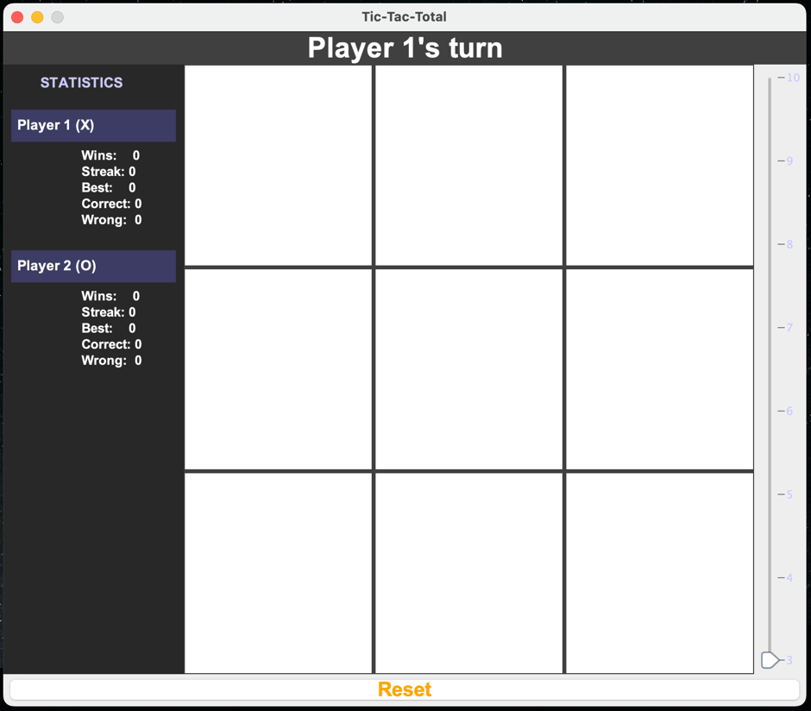
When moved up and down the slider, the following occurs:
- The newly appropriate grid size is displayed
- The game is reset (all symbols removed) and new game is started (which included its own calls such as selecting a new random starting player)
Throughout the duration of the session, this panel accurately displays each players statistics for this session. Including:
- Total number of wins
- Current win streak
- Highest win streak
- Total number of correctly answered questions
- Total number of incorrectly answered questions

Each tile is represented as button a button. Appropriately displayed in it corresponding number to the Jslider (e.g., 3x3).
When clicked this button places the current player’s symbol in the tile and then disabled the opportunity for the button to be clicked again and subsequently unable to change the symbol.

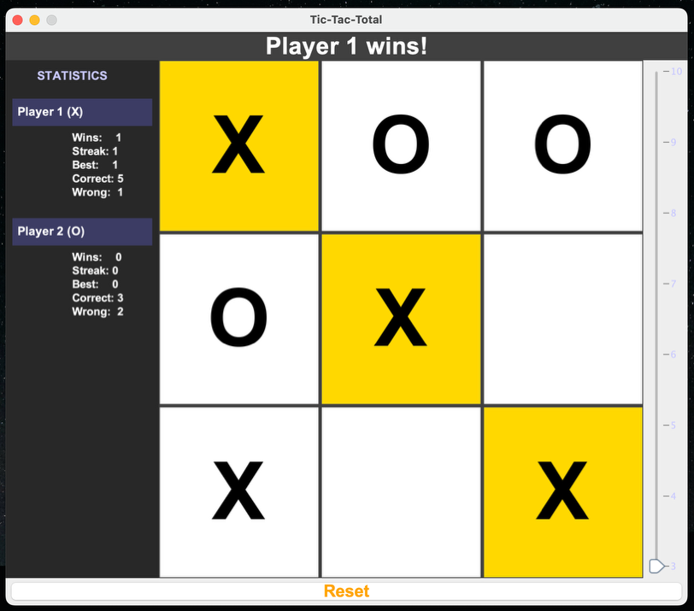
When clicked this button resets the game back to its original starting state. It moves all symbols from the tiles and selects a new random starting player. It can be clicked at any time.

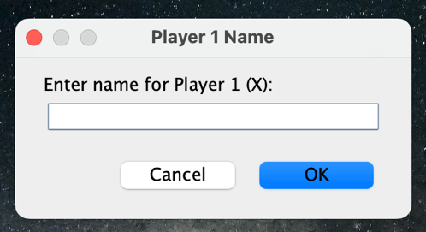
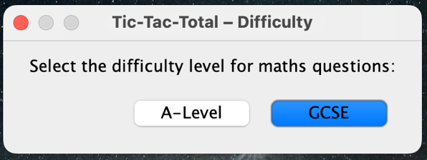
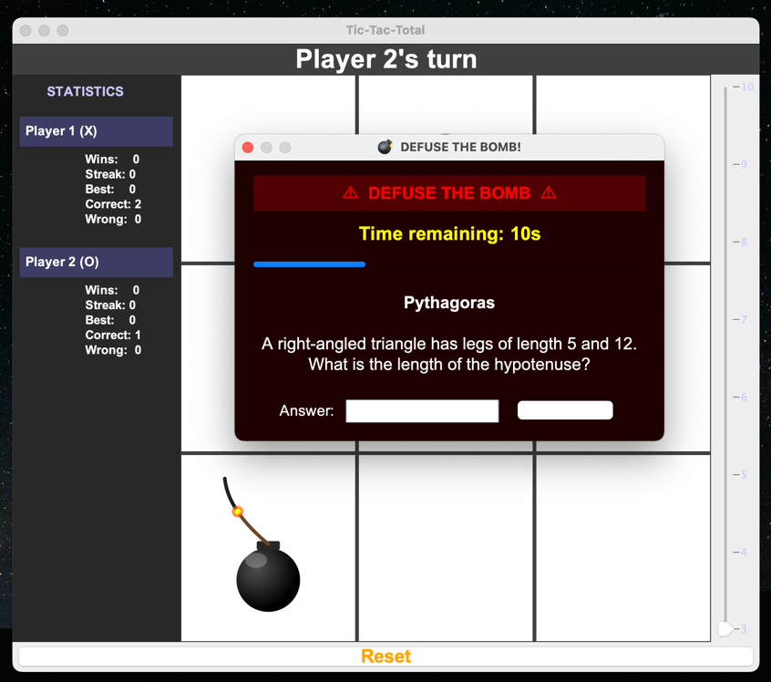

Section D: Testing
Test Table
Test No. | Success Criteria | Description | Expected Outcome | Observed Outcome | Remedial Action
1 | 11, 12 | Launch the application and observe the first dialog that appears. | A difficulty-selection dialog appears before the game board is visible. It presents exactly two labelled buttons: "GCSE" and "A-Level". | On launch, a dialog titled "Tic-Tac-Total – Difficulty" appeared immediately, before the game board was shown. It displayed exactly two option buttons labelled "GCSE" and "A-Level". | None
2 | 13, 14 | After selecting GCSE difficulty, observe the player-name dialogues. Then cancel (dismiss) both dialogues to test default-name fallback. | Two successive name-entry dialogs appear, one for Player 1 and one for Player 2. Cancelling or leaving the field blank results in the default names "Player 1" and "Player 2" being used. | Two input dialogs appeared in sequence. When both were dismissed without entering text, the game started with players named "Player 1" and "Player 2" as shown in the statistics panel and turn label. | None
3 | 15 | After completing the start-up dialogs, inspect the main application window. | The window title bar reads "Tic-Tac-Total". | The title bar read "Tic-Tac-Total". | None
4 | 18, 19, 20, 21, 22 | Observe the overall layout of the main window once the game starts. | The window contains five regions: header at the top (bold white text on dark background), statistics panel on the left, game board in the centre, Reset button at the bottom (dark background, legible text), and a vertical grid-size slider on the right. | All five regions were present and correctly positioned. The header displayed centred bold white text on a dark grey background. The Reset button had dark background and was appropriately labelled. The slider was vertical and appeared on the right-hand side. The statistics panel was permanently visible on the left. | None
5 | 23, 27, 29 | Start the game and examine the initial board state. | The game board displays a 3×3 grid (the default size). All 9 tiles appear as blank white buttons with no text. | On first launch a 3×3 grid was displayed. All tiles were blank white with no symbols or text. | None
6 | 24, 25, 26 | Move the grid-size slider to each value between 3 and 10 and observe the result. | For every integer position from 3 to 10, the board immediately rebuilds as a square grid of that size and a new round begins. No sizes outside this range are selectable. | Moving the slider through all positions (3, 4, 5, 6, 7, 8, 9, 10) caused the board to rebuild at the corresponding size each time. The slider stops at 3 (minimum) and 10 (maximum). A new round began immediately at each new size. | None
7 | 28 | Set the grid size to 10×10 and observe the tile symbols. | The "X" and "O" symbols on claimed tiles remain clearly legible — font size scales down automatically so that symbols are not clipped or too small to read. | Symbols on a 10×10 grid were smaller than on a 3×3 grid but remained fully legible and were correctly centred within each tile. No clipping or truncation was observed. | None
8 | 30, 31 | Click an empty standard tile on a 3×3 board. Answer the maths question correctly. Then attempt to click the same (now occupied) tile again. | After a correct answer the clicked tile displays the current player's symbol (X or O) centred in the tile. The second click on the occupied tile has no effect. | The symbol appeared correctly in the tile after a correct answer. Clicking the occupied tile again produced no visible change and the turn label remained unchanged. | None
9 | 33, 34 | Click an empty standard tile and answer the maths question correctly. | A maths question dialog appears immediately on clicking the tile. On submitting a correct answer, the tile flashes green and the symbol is placed. | The maths question dialog appeared instantly on tile click. After entering the correct answer, the tile turned green. The symbol was visible in the tile. | None
10 | 35, 36 | Click an empty standard tile and deliberately enter a wrong answer to the maths question. | The tile flashes red for approximately 1 500 milliseconds, displaying the correct answer during the flash. After the flash, the turn passes to the other player and the turn label updates accordingly. | The tile turned red and displayed the correct answer text. After the flash cleared, the turn label updated to show the other player's name followed by "'s turn". | None
11 | 32, 37 | Click a tile, answer correctly, and verify the win-check occurs before the turn changes. While the green flash is running, attempt to click another tile. | After a correct answer, the program checks for a win before switching turns. Clicks on other tiles during the green flash are ignored. | After placing a symbol, the program immediately ran a win check (evidenced by the winning animation triggering when a line was completed). Clicking other tiles during the flash had no effect. | None
12 | 38 | Play several rounds at GCSE difficulty and record the topics of standard questions that appear. | Over multiple questions, all seven GCSE standard topics appear: linear equations, percentages, area of rectangles/triangles, mean of a dataset, powers and indices, algebraic substitution, and speed/distance/time. | All seven question types were observed across a session of approximately 30 questions at GCSE level. | None
13 | 39 | Play several rounds at A-Level difficulty and record the topics of standard questions that appear. | Over multiple questions, all seven A-Level standard topics appear: differentiation (power rule), second derivatives, stationary points, definite integration, logarithms, binomial coefficients, and inverse-trigonometric angles. | All seven A-Level question types were observed across a session of approximately 30 questions at A-Level level. | None
14 | 40 | Answer the same type of question (e.g. linear equation) twice in the same session and compare the numerical values. | The numbers in the two questions differ — parameters are freshly randomised each time even when the topic type repeats. | Two consecutive linear-equation questions were generated with different coefficients and constant terms, confirming that numerical parameters are re-randomised on each generation. | None
15 | 41 | Enter the correct answer to a question with leading/trailing spaces and mixed case (where the answer is a string). | The answer is accepted despite the extra whitespace and differing letter case. | Testing an answer like " 42 " (with spaces) and an answer typed in the wrong case for a string response were both accepted as correct. | None
16 | 42 | Inspect a question that has more than one valid answer form (e.g. "0.5" or "1/2"). Enter each accepted form in separate attempts. | Both alternative forms are accepted as correct. | For a relevant question in the GCSE bank, both "0.5" and "1/2" were accepted as correct answers when entered separately. | None
17 | 43, 44 | Start a game on a 5×5 grid (which has 3 bomb tiles). Observe all tiles before clicking. Then click a bomb tile. | Before being clicked, bomb tiles look identical to empty standard tiles — completely blank and white. Clicking one reveals the bomb graphic and begins the fuse-burn animation on the tile. | All tiles appeared identical before any were clicked. Clicking a bomb tile caused it to reveal a bomb graphic and begin its animated fuse-burn sequence. The tile's background changed to show the animation. | None
18 | 45 ,46, 47 | Click a bomb tile and observe the dialog that appears. | Simultaneously with the bomb animation beginning, a bomb-diffuse dialogue appears. It shows the harder maths question text, an answer text field, a "DEFUSE!" submit button, a countdown label starting at "35s", and a progress bar. | The diffuse dialog appeared at the same time as the bomb animation began. It contained the question, an input field, the "DEFUSE!" button, and a countdown starting at 35 seconds with a visible orange progress bar. | None
19 | 48 | In the bomb-diffuse dialog, wait until the countdown reaches 5 seconds and observe the countdown label colour. | The countdown label changes from yellow to red when 5 or fewer seconds remain. | The label was yellow at 35 s and changed to red at exactly 5 s remaining. | None
20 | 49 | At GCSE difficulty, observe several bomb-diffuse questions across multiple rounds. | All four harder GCSE bomb-diffuse topics appear: quadratic equations, Pythagoras' theorem, simultaneous equations, and nth-term sequences. | All four harder GCSE topics were observed across multiple bomb clicks in a GCSE session. | None
21 | 50 | At A-Level difficulty, observe several bomb-diffuse questions across multiple rounds. | All three harder A-Level bomb-diffuse topics appear: geometric series sums, chain-rule differentiation, and harder definite integrals. | All three harder A-Level topics were observed across multiple bomb clicks in an A-Level session. | None
22 | 51, 52 | Click a bomb tile and answer the diffuse question correctly. | The bomb animation stops, the bomb tile converts to a blank standard tile, and the current player's symbol is placed in that cell. A win/draw check is then run. | After a correct diffuse answer, the bomb graphic disappeared and the tile became a normal white tile containing the player's symbol. The win check ran immediately after (evidenced by a win being detected if that cell completed a line). | None
23 | 53, 54, 55 | Click a bomb tile and deliberately give a wrong answer (or allow the timer to expire). Observe the explosion and its aftermath. | The bomb detonates — an explosion particle animation plays. Once the animation completes, all tiles in the 3×3 area surrounding the bomb cell (including the bomb cell itself) are cleared of any symbols, and empty standard tiles replace them. | After a wrong answer, the explosion animation played. Upon completion, the 3×3 area centred on the bomb was fully cleared: all surrounding symbols were removed and all cells (including the bomb cell) became blank standard tiles. | None
24 | 57 | Trigger a bomb explosion and attempt to click any tile during the animation. | All tile clicks are completely blocked while the explosion animation is running. No clicks are processed until the animation fully completes. | Clicking various tiles during the explosion animation had no effect. Once the animation finished and the turn label updated, tile clicks were accepted normally. | None
25 | 58 | Trigger a bomb explosion (by failing to diffuse) and observe whose turn it is after the animation completes. | The turn passes to the other player once the explosion animation finishes. The turn label updates to show the new active player. | After the explosion animation ended, the turn label changed to display the other player's name followed by "'s turn". | None
26 | 59, 61 | Start a new round on a 5×5 grid and inspect the board for bomb placement. Reset multiple times and observe new placements. | Bomb tiles are placed at random positions on the grid at the start of every round. No two bombs share the same cell. Repeated resets show different placements. | On each reset, bomb positions changed. Running the game multiple times confirmed no duplicate bomb positions within the same round. | None
27 | 62, 63 | On a 3×3 grid, place three X symbols in a row. On a 5×5 grid, place four X symbols in a row. On a 7×7 grid, place five X symbols in a row. On a 9×9 grid, place six X symbols in a row. | A win is detected in each case at the exact required line length (3, 4, 5, 6 respectively), and not before. | Wins were detected at the correct line lengths for each grid size. Placing one fewer symbol in a line did not trigger a win. | None
28 | 62 | Verify that wins are detected in all directions: a row, a column, and both diagonals (top-left to bottom-right, and top-right to bottom-left). | A win is detected and announced for a completing move regardless of whether the line is horizontal, vertical, or diagonal. | Wins were detected and celebrated for lines in all four directions tested. | None
29 | 64, 65, 66 | Complete a winning line and observe the visual and label feedback. Then attempt to click a tile after the win is declared. | The tiles forming the winning line flash gold. The header label displays "[Winner's name] wins!". All tile clicks are ignored after the win. | After completing a line, the winning tiles flashed gold repeatedly. The header showed the correct winner message. Clicking any tile afterwards had no effect. | None
30 | 67, 68 | On a 3×3 grid, fill every cell without completing a line (create a draw). | When all 9 cells are filled and no winner has been found, the game records a draw and the header displays a draw message (e.g. "It's a draw!"). | After filling all tiles on a 3×3 grid with no winning line, the header changed to display "It's a draw!". | None
31 | 69, 70 | Reset the game 5 times and record which player goes first each time. | The starting player is chosen at random — over multiple rounds, both Player X and Player O are selected as the first player. The header displays "[Player name]'s turn" at the start of each round. | Over 10 resets, Player X started first 6 times and Player O started first 4 times, confirming random selection. The turn label always updated immediately on round start. | None
32 | 71 | Answer a standard tile question correctly. Verify that after the win check (assuming no win), the turn switches. | After a correct answer, if no win or draw occurs, the turn label changes to the other player's name followed by "'s turn". | After placing a symbol with a correct answer and no win being triggered, the turn label updated to show the other player's name. | None
33 | 72 | Answer a standard tile question incorrectly. Verify the turn switches after the red flash. | After red flash completes, the turn label changes to the other player's name followed by "'s turn". | After the red flash ended, the turn label updated to show the other player's name. | None
34 | 73, 74 | Verify turn-switching after both bomb outcomes. First diffuse a bomb (correct answer) and confirm turn switches if no win. Then fail a bomb (wrong answer) and confirm turn switches after the explosion animation. | After a successful diffuse (with no win), the turn passes to the other player. After a failed diffuse, the turn passes to the other player once the explosion animation completes. | Both outcomes were verified: after a diffuse the turn label updated to the other player; after an explosion the turn label updated only once the animation had fully completed. | None
35 | 75, 76, 77 | Win two rounds in a row as the same player. Check the score, win streak, and best streak in the statistics panel after each win. | The winning player's score increments by 1 per win. The win streak increments by 1 per consecutive win. The best streak equals or exceeds the current streak and never decreases. | After two consecutive wins for Player X, the statistics panel showed: Score = 2, Streak = 2, Best = 2. After Player O won the next round, Player X's streak reset to 0 but Best remained at 2. | None
36 | 78, 79, 80, 81 | Answer several maths questions correctly and incorrectly across both players. Observe the statistics panel after each answer. | The statistics panel updates in real time after every answered question. The correct-answers count increments when a correct answer is given; the wrong-answers count increments on incorrect answers or expired bomb timers. All five statistics are visible for both players. | The stats panel updated after every question — correct and wrong counts changed immediately. All five statistics (wins, streak, best streak, correct, wrong) were displayed for both players throughout the session. | None
37 | 82, 83, 84 | Press the Reset button during an active game. Observe the board state, which player goes first, and whether statistics are preserved. | The board clears immediately and a new round begins at the same grid size with a randomly chosen starting player. Player scores, streaks, and answer counts remain unchanged. | Pressing Reset cleared the board and started a new round. The grid size was unchanged. The starting player changed on some resets (random). All statistics in the side panel were preserved from before the reset. | None

Section E: Evaluation
Analysis of Criteria
# | Criteria | Description | Met
1 | The game must be easy to pick up and play without reading any documentation — a new player must be able to understand what to do from the starting dialogs alone. | The program opens with a clearly labelled difficulty-selection dialog ("GCSE" / "A-Level") followed by two name-entry dialogs. The header then displays whose turn it is, and the turn label updates after every action. A new player does not need to refer to any external document to make their first move. | ✅
2 | The correct-answer and incorrect-answer visual feedback must be immediately clear to both players without any explanation. | A correct answer produces a bright green tile flash; an incorrect answer produces a red flash and displays the correct answer as text on the tile for 1 500 ms. The contrasting colours are universally understood as pass/fail signals and require no explanation. | ✅
3 | The bomb mechanic must feel tense and exciting; the countdown timer and explosion animation must create a genuine sense of urgency for the player trying to defuse it. | The bomb-diffuse dialog presents a 35-second countdown with a depleting progress bar. At 5 seconds the label turns red. On failure, an explosion particle animation fires before the area is cleared, providing a satisfying and impactful consequence. | ✅
4 | The interface must look visually consistent throughout — fonts, colours, and layout must form a coherent style at every stage of the game. | All UI components use Arial Bold as the primary font. The dark grey header and statistics panel, white tile background, and orange accent on the Reset button are applied uniformly across start-up dialogs, the main board, and the bomb-diffuse dialog. The dark red background of the bomb-diffuse dialog distinguishes it as a special event while remaining visually coherent. | ✅
5 | The difficulty levels must feel appropriately challenging — GCSE questions must be suitable for GCSE students and A-Level questions must be noticeably harder, appropriate for students studying A-Level Mathematics. | GCSE standard questions draw from topics such as linear equations, percentages, and speed/distance/time. A-Level standard questions draw from differentiation, integration, logarithms, and binomial coefficients — topics that require A-Level knowledge to solve reliably. The harder bomb-diffuse questions at each level are further stepped up, maintaining a clear and appropriate progression. | ✅
6 | The game must feel fair to both players; neither player must have a structural advantage due to their symbol, the layout of the grid, or the selection of questions. | Questions are generated independently for each player from the same pool with freshly randomised parameters. The starting player is chosen randomly at the start of every round. Bomb positions are placed randomly and the grid is symmetric — neither symbol (X or O) has a visual or mechanical advantage. | ✅
7 | The statistics panel must be readable at a glance without obscuring or distracting from the game board. | The statistics panel is positioned to the left of the game board in a dedicated region and occupies a fixed narrow column. Text sizes are large enough to be read without squinting but the panel does not compete with the board for visual attention. All five statistics for both players are labelled clearly. | ✅
8 | The bomb explosion animation must be visually impressive and must clearly communicate that tiles in the surrounding area have been cleared. | The explosion is rendered by BombAnimationEngine, which generates multiple particle bursts radiating from the bomb cell. Once the animation completes, the 3×3 area is visibly cleared — tiles revert to blank white — making the area-clear effect unmistakably obvious. | ✅
9 | The transition between rounds (after a win, draw, or reset) must feel immediate — there must be no noticeable lag or visual disruption when a new round begins. | Pressing Reset or starting a new round rebuilds the grid synchronously on the EDT. The new grid appears instantaneously with no blank frames or flicker. | ✅
10 | The answer-feedback flash must be long enough for both players to read the correct answer comfortably but short enough that it does not disrupt the pace of play. | The green (correct) flash lasts 600 ms — just long enough to register visually. The red (incorrect) flash lasts 1 500 ms — sufficient for both players to read the correct answer on the tile. Neither duration is long enough to cause frustration between turns. | ✅
11 | On launch, the program must display a difficulty-selection dialog before the game board is shown. | TicTacTotalUI calls the difficulty dialog inside its constructor before making the JFrame visible, so the dialog always appears before the board is rendered. | ✅
12 | The difficulty-selection dialog must offer exactly two options: "GCSE" and "A-Level". | The dialog is built with two JButton components labelled "GCSE" and "A-Level" and no other selectable options. | ✅
13 | After difficulty selection, the program must present an input dialog asking for the name of Player 1, followed by a second dialog asking for the name of Player 2. | Two successive JOptionPane.showInputDialog calls collect the names before the game board becomes interactive. | ✅
14 | If a player leaves their name field blank or cancels the dialog, the program must automatically substitute the default name "Player 1" or "Player 2" respectively. | The returned string is checked with == null (cancel) and trim().isEmpty() (blank); if either condition is true, the default name is used. | ✅
15 | The application window title must read "Tic-Tac-Total". | The Runner constructs the JFrame with new JFrame("Tic-Tac-Total"). | ✅
16 | The main window must contain five distinct regions: a header banner at the top, a statistics panel on the left, the game board in the centre, a Reset button at the bottom, and a grid-size slider on the right. | TicTacTotalUI uses a BorderLayout: the header occupies NORTH, the stats panel WEST, the game board CENTER, the Reset button SOUTH, and the slider EAST. | ✅
17 | The header label must display centred text in bold white font on a dark background. | The header JLabel has its foreground set to Color.WHITE, its font to new Font("Arial", Font.BOLD, 28), and its background to a dark grey Color(45, 45, 45) with setOpaque(true). Text alignment is CENTER. | ✅
18 | The Reset button must have a dark background and be clearly labelled "Reset". | The Reset button is constructed as new JButton("Reset") and styled with a dark background (Color(45, 45, 45)) and contrasting orange foreground. | ✅
19 | The grid-size slider must be oriented vertically, positioned to the right of the game board. | The JSlider is created with SwingConstants.VERTICAL orientation and added to the EAST region of the layout. | ✅
20 | The statistics panel must be positioned to the left of the game board and must always be visible during play. | The StatsPanel is added to the WEST region. It is never hidden or replaced at any point during a session. | ✅
21 | The game board must display a square grid of tiles, where every cell contains exactly one tile. | GamePanel.buildGrid() iterates over every (row, col) pair from 0 to gridSize - 1 and places exactly one Tile instance (either StandardTile or BombTile) per cell in a GridLayout. | ✅
22 | The grid must support all sizes from 3×3 to 10×10 inclusive. | The JSlider is set with setMinimum(3) and setMaximum(10). GameModel and BombManager both accept any grid size from 3 to 10. | ✅
23 | The slider on the right of the window must allow the player to select any grid size between 3 and 10. | The slider has minor tick spacing of 1 and setPaintTicks(true) so every integer from 3 to 10 is reachable. A ChangeListener fires on every slider movement and calls GameController.changeGridSize(). | ✅
24 | When the grid-size slider is moved to a new value, the board must immediately reset and a new round must begin at the new grid size. | The ChangeListener calls GameController.changeGridSize(newSize) which calls GamePanel.rebuildGrid(newSize) synchronously, replacing all tiles and restarting the round immediately. | ✅
25 | The game must start with a default grid size of 3×3. | TicTacTotalUI initialises the slider with setValue(3) and creates the initial GameModel and GamePanel with gridSize = 3. | ✅
26 | Tile font sizes must scale dynamically with the current grid size so that symbols (X and O) remain clearly legible on all supported grid sizes. | GamePanel.doLayout() is overridden; after the standard Swing layout pass it calculates a font size proportional to the tile height and calls tile.setFontSize(fontSize) on every tile, ensuring symbols scale with the available cell size. | ✅
27 | Empty standard tiles must appear as plain white buttons with no text. | StandardTile.draw() sets setText("") and setBackground(Color.WHITE) when the tile is empty, producing a plain blank appearance. | ✅
28 | A claimed standard tile must display the claiming player's symbol (X or O) centred inside the tile. | StandardTile.setSymbol(sym) stores the symbol and calls draw(), which calls setText(symbol). The symbol is drawn centred manually in Tile.paintComponent() to prevent Swing from truncating it with "...". | ✅
29 | Clicking an already-occupied tile must have no effect on the game state. | In GameController.handleTileClick(), the first check is if (!tile.isEmpty()) return; — occupied tiles are ignored immediately. | ✅
30 | Clicking any tile while an animation is in progress (bomb explosion or answer flash) must have no effect. | GameController maintains an animationInProgress boolean flag. Every tile-click handler checks this flag at entry and returns without action if it is true. | ✅
31 | Clicking an empty standard tile must immediately present a maths question to the current player in a dialog. | GameController.handleTileClick() calls MathQuestionDialog.show()  synchronously on the EDT, which blocks until the player submits an answer. | ✅
32 | If the player answers a standard-tile question correctly, their symbol must be placed in that tile and the tile must flash green for exactly 600 milliseconds. | On a correct answer the symbol is set via tile.setSymbol(sym) and a javax.swing.Timer with a delay of 600 ms fires once to restore the white background. | ✅
33 | If the player answers a standard-tile question incorrectly, the tile must flash red for exactly 1,500 milliseconds, and during that flash the tile must display the correct answer. | On an incorrect answer, tile.setBackground(Color.RED) and tile.setText(...) display the correct answer; a Timer with a delay of 1500 ms restores the tile's original state. | ✅
34 | After an incorrect answer on a standard tile, the turn must pass to the other player once the red flash completes. | The Timer callback for the 1500 ms red flash calls GameController.switchTurn() and StatsPanel.refresh() only after the delay has elapsed. | ✅
35 | After a correct answer on a standard tile, a win/draw check must be performed before the turn switches. | Immediately after placing the symbol, GameController calls GameModel.checkWin() and GameModel.checkDraw() before any turn-switching logic executes. | ✅
36 | Standard questions at GCSE difficulty must be drawn randomly from at least the following topic types: linear equations, percentages, area of rectangles and triangles, mean of a dataset, powers and indices, algebraic substitution, and speed/distance/time. | MathQuestionBank.getStandardQuestion(GCSE) randomly selects from a list of seven generator methods, one per required topic. All seven are implemented with randomised parameters. | ✅
37 | Standard questions at A-Level difficulty must be drawn randomly from at least the following topic types: differentiation (power rule), second derivatives, stationary points, definite integration, logarithms, binomial coefficients, and inverse-trigonometric angles. | MathQuestionBank.getStandardQuestion(A_LEVEL) randomly selects from a list of seven generator methods covering all seven required A-Level topics. | ✅
38 | Each time a question is needed, a topic type must be selected at random, and the numerical parameters of that question must be freshly generated at random. | Every call to getStandardQuestion() or getBombQuestion() uses new Random() (or an instance-level Random) to pick a topic index and then independently randomises all numerical values (coefficients, bases, dimensions, etc.) before constructing the MathQuestion object. | ✅
39 | Answer checking must be case-insensitive and must strip leading and trailing whitespace from the player's input before comparing it against the correct answer. | MathQuestion.isCorrect(input) normalises the input with input.trim().toLowerCase() and compares it against each accepted answer (also lower-cased) before returning the result. | ✅
40 | Where a question has more than one valid way to express the correct answer, all accepted forms must be stored with the question and any one of them must be accepted as correct. | MathQuestion stores a List<String> acceptedAnswers. isCorrect() iterates through the entire list and returns true if any element matches the normalised input. | ✅
41 | Bomb tiles must be hidden — before being clicked, a bomb tile must appear visually identical to an empty standard tile. | BombTile.draw() renders a plain white background with no text when isActivated is false, exactly matching the appearance of an empty StandardTile. | ✅
42 | Clicking a bomb tile must trigger the bomb: the tile must reveal its bomb graphic and begin an animated fuse-burn sequence. | Clicking a BombTile calls activate(), which sets isActivated = true and starts the javax.swing.Timer inside BombAnimationEngine that drives the frame-by-frame fuse animation. | ✅
43 | Simultaneously with the bomb animation beginning, a dedicated bomb-diffuse dialogue must be displayed. | GameController.handleBombClick() calls tile.activate() and then immediately constructs and shows BombDiffuseDialogue — both happen in the same EDT call, so the dialogue appears at the same time as the animation starts. | ✅
44 | The bomb-diffuse dialog must show the question, an answer input field, and a "DEFUSE!" submit button. | BombDiffuseDialogue contains a JLabel for the question text, a JTextField for the answer, and a JButton labelled "DEFUSE!". | ✅
45 | The bomb-diffuse dialog must display a countdown timer starting at 35 seconds, with a visible progress bar that decreases as time passes. | A javax.swing.Timer fires every 1000 ms, decrementing the counter from 35. A JProgressBar is initialised to maximum = 35 and its value decrements in step with the counter label. | ✅
46 | When 5 or fewer seconds remain on the countdown, the countdown label must change colour to red to warn the player. | Inside the timer callback, if (timeLeft <= 5) countdownLabel.setForeground(Color.RED); is checked on every tick. | ✅
47 | Bomb-diffuse questions at GCSE difficulty must be drawn from harder GCSE topics, covering at least: quadratic equations, Pythagoras' theorem, simultaneous equations, and nth-term sequences. | MathQuestionBank.getBombQuestion(GCSE) randomly selects from a separate pool of four harder GCSE generator methods, covering all four required topics. | ✅
48 | Bomb-diffuse questions at A-Level difficulty must be drawn from harder A-Level topics, covering at least: geometric series sums, chain-rule differentiation, and harder definite integrals. | MathQuestionBank.getBombQuestion(A_LEVEL) randomly selects from a pool of three harder A-Level generator methods covering all three required topics. | ✅
49 | If the player answers the bomb-diffuse question correctly within the time limit, the bomb must be diffused: the bomb tile must convert to an empty standard tile and the player's symbol must be placed in that cell. | On a correct diffuse answer, GameController calls GamePanel.convertBombToStandard(row, col), which replaces the BombTile in the grid with a new StandardTile, then calls setSymbol(sym) on it. | ✅
50 | After a successful diffuse, the game must perform a win/draw check. | Immediately after placing the symbol on the converted tile, GameController calls checkWin() and checkDraw() before any further action. | ✅
51 | If the player answers the bomb-diffuse question incorrectly, or if the countdown reaches zero, the bomb must detonate. | Both the incorrect-answer path and the timer-expiry path in BombDiffuseDialogue call GameController.handleBombDetonation(row, col) — the same detonation sequence runs regardless of the failure reason. | ✅
52 | When a bomb detonates, it must trigger an explosion particle animation before clearing the board. | BombTile.triggerExplosion() starts the particle-burst phase of BombAnimationEngine; the area-clear only occurs inside the AnimationCompleteListener callback, which fires after the animation finishes. | ✅
53 | Once the explosion animation completes, all tiles in the 3×3 area surrounding the bomb (including the bomb cell itself) must be cleared — any symbols must be removed from both the view and the internal board state. | Inside the AnimationCompleteListener, GameController iterates over every (r, c) in [row-1, row+1] × [col-1, col+1], calls GameModel.clearCell(r, c) to update the model and GamePanel.resetTile(r, c) to reset the view tile. | ✅
54 | If a neighbouring bomb tile falls within the 3×3 blast radius of an exploding bomb, that neighbouring bomb must also be converted to an empty standard tile (it does not itself explode). | The area-clear loop checks whether a neighbour is a BombTile; if so, it calls GamePanel.convertBombToStandard(r, c) to replace it with a blank standard tile, rather than triggering a second explosion. | ✅
55 | All tile clicks must be blocked for the entire duration of a bomb explosion animation. | GameController sets animationInProgress = true when a bomb detonation begins. It is only reset to false inside the AnimationCompleteListener callback that fires when the last animation frame completes. | ✅
56 | After the explosion animation and area-clear complete, the turn must pass to the other player. | The final action inside the AnimationCompleteListener callback (after clearing the board and resetting the flag) is a call to GameController.switchTurn(). | ✅
57 | At the start of every round, bomb tiles must be placed at randomly chosen positions on the grid. | BombManager.placeBombs() uses java.util.Random to generate candidate (row, col) pairs and is called at the start of every new round (construction or reset). | ✅
58 | The number of bombs placed must match the specified table exactly (3→1, 4→2, 5→3, 6→5, 7→9, 8→12, 9→16, 10→20). | BombManager.getBombCount(gridSize) looks up the count in a hard-coded 8-entry BOMB_COUNTS array that matches the intended values. | ✅
59 | No two bombs must be placed in the same cell. | BombManager.placeBombs() stores occupied positions in a HashSet<String> and rejects any randomly generated position that is already in the set, repeating until a unique cell is found. | ✅
60 | The program must detect a win whenever a player places a symbol that completes a consecutive line of the required length in any row, any column, or either diagonal. | GameModel.checkWin() runs four separate scans — across rows, down columns, along the top-left-to-bottom-right diagonal, and along the top-right-to-bottom-left diagonal — returning the winning line if any reaches winLength consecutive matching symbols. | ✅
61 | The required win length must follow the specified table (grids 3–4: win 3; 5–6: win 4; 7–8: win 5; 9–10: win 6). | GameModel.setGridSize() calculates winLength from the grid size using a conditional that matches the intended values. | ✅
62 | When a win is detected, the tiles that form the winning line must be highlighted with a gold flashing animation. | GameController receives the list of winning Point objects from checkWin() and passes them to WinFlashAnimation, which alternates tile backgrounds between gold and white on a repeating javax.swing.Timer. | ✅
63 | When a win is detected, the header must display a message naming the winner (e.g. "Alice wins!"). | GameController.handleWin() calls TicTacTotalUI.setHeaderText(name + " wins!") immediately after the win is detected. | ✅
64 | When a win is detected, all tile clicks must be ignored until a new round begins. | GameController sets gameOver = true on a win. Every tile-click handler checks this flag and returns without action while it is true. The flag is cleared only when startNewRound() is called. | ✅
65 | When all tiles are occupied and no winning line has been found, the game must record a draw. | GameModel.checkDraw() returns true when movesMade == gridSize * gridSize and checkWin() returns null. | ✅
66 | When a draw occurs, the header must display a draw message (e.g. "It's a draw!"). | GameController.handleDraw() calls TicTacTotalUI.setHeaderText("It's a draw!") when checkDraw() returns true. | ✅
67 | At the start of each new round, the first player to take a turn must be selected at random. | GameController.startNewRound() calls currentPlayerIndex = new Random().nextInt(2) to pick 0 or 1 with equal probability, then sets the header accordingly. | ✅
68 | The header must always display whose turn it currently is during active play. | Every call to GameController.switchTurn() and startNewRound() ends with TicTacTotalUI.setHeaderText(currentPlayer.getName() + "'s turn"). | ✅
69 | After a correct answer on a standard tile, the active player's symbol is placed and a win/draw check is run; if the game continues, the turn must then switch to the other player. | After placing the symbol and running checkWin() / checkDraw(), if neither returns a terminal result, GameController calls switchTurn(). The win/draw path skips switchTurn() and calls handleWin() or handleDraw() instead. | ✅
70 | After an incorrect answer on a standard tile, the turn must switch to the other player immediately once the red flash has finished. | The 1500 ms Timer callback calls switchTurn() when it fires, ensuring the turn change happens only after the flash has completed. | ✅
71 | After a bomb diffuse, if the game continues, the turn must switch to the other player. | After a successful diffuse and win/draw check (with no terminal result), GameController calls switchTurn(). | ✅
72 | After a bomb detonation, the turn must switch to the other player once the explosion animation is complete. | The AnimationCompleteListener callback calls switchTurn() as its final action, after all area-clear work has been done. | ✅
73 | Each player must have a rounds-won score (initialised to 0) that increments by exactly 1 each time they win a round. | The Player class holds an int wins field initialised to 0. GameController.handleWin() calls currentPlayer.incrementWins() which adds exactly 1. | ✅
74 | Each player must have a current win streak that increments by 1 after each consecutive round win and resets to 0 after a loss or a draw. | Player holds int streak. handleWin() calls incrementStreak() on the winner; handleDraw() and handleWin() both call resetStreak() on the losing/drawing player. | ✅
75 | Each player must have a best-streak record that stores the highest consecutive win streak the player has reached in the current session; it must never decrease. | Player.incrementStreak() calls if (streak > bestStreak) bestStreak = streak; after incrementing, so bestStreak only ever increases. | ✅
76 | Each player must have a correct-answers count that increments by 1 every time they answer any maths question correctly (standard or bomb-diffuse). | Both the standard-tile correct-answer handler and the bomb-diffuse correct-answer handler call currentPlayer.incrementCorrect() before any other action. | ✅
77 | Each player must have a wrong-answers count that increments by 1 every time they answer incorrectly or let the bomb-diffuse countdown expire. | The standard-tile incorrect path, the bomb-diffuse incorrect path, and the bomb-diffuse timer-expiry path all call currentPlayer.incrementWrong(). | ✅
78 | The statistics panel must show all five statistics for both players: rounds won, current win streak, best streak, correct answers, and wrong answers. | StatsPanel.refresh() reads all five fields from each Player object and updates the corresponding JLabel widgets for both players simultaneously. | ✅
80 | A "Reset" button must be visible at the bottom of the window throughout the entire game session. | The Reset button is placed in the SOUTH panel of the BorderLayout and is never hidden or removed. It remains enabled and visible in all game states. | ✅
81 | Pressing the Reset button must immediately start a new round with the same grid size, resetting the board and picking a new random starting player. | The Reset ActionListener calls GameController.startNewRound() which rebuilds the grid at the current size and calls currentPlayerIndex = new Random().nextInt(2). | ✅
82 | Pressing the Reset button must not reset either player's score, win streaks, or answer statistics — those must persist across rounds within the session. | startNewRound() only resets the GameModel board state and rebuilds GamePanel. The Player objects (which hold all statistics) are never re-constructed or reset during a Reset. | ✅

End User Feeback
The A-Level student stated that the completed program was more engaging than traditional revision methods, particularly because of the competitive aspect and the requirement to answer questions in order to make a move. They commented that “the game makes revision feel much less repetitive because you are concentrating on trying to win as well as answering the maths questions.” They also felt that the timed bomb questions were especially useful, explaining that “the timed questions made it feel more like an exam, but because it was part of the game it was less stressful.” In addition, they stated that the inclusion of more challenging topics, such as differentiation and integration, made the game relevant to A-Level study. This suggests that the program was successful in addressing the lack of engagement and confidence identified during the interview stage.
The GCSE student also responded positively to the game-based approach and stated that they would be more likely to use this program at home than revise from a textbook or worksheet. They explained that “normally I would not revise maths unless I had to, but this made it more enjoyable because it felt like a game rather than work.” They particularly liked the immediate feedback and commented that “it was helpful being told straight away if I got the answer wrong, because then I could learn from it immediately.” In addition, they found that being able to play against another person increased their motivation, stating that “playing against someone else made me want to keep going and try harder.” This indicates that the program successfully met the needs of users who struggle with motivation and independent revision.

Further Development
A suitable future development would be the introduction of additional tile types. For example, a freeze tile could be added alongside the existing bomb tiles. When selected, the player would answer a mathematics question as normal; however, if answered correctly, the opposing player would lose their next turn or be required to answer an additional question before continuing. This would increase the strategic aspect of the game and further improve engagement. As the program already uses an abstract Tile class, this could be implemented efficiently by creating a new FreezeTile subclass with its own draw() and onClick() methods.
Another possible improvement would be the addition of online multiplayer. Currently, the game can only be played by two users on the same device. Allowing players to connect over a network would make the program more accessible, particularly for students revising from different locations. Since the game logic is already separated from the graphical interface within the GameController, this could be achieved with relatively few changes by introducing a remote player class that implemnets the same interface as the existing player class but relay moves over a network connection.
Finally, the program could be extended by adding a persistent leaderboard. At present, statistics such as wins, streaks, and correct answers are only stored for the duration of the current session. Saving this information between sessions would allow users to monitor their long-term progress and would further encourage competition. This could be achieved by writing player statistics to an external file and loading them when the program starts.

Final Thoughts
Overall, I am very pleased with the final product and believe that it successfully achieves its aim of making mathematics revision more engaging and effective. The completed program meets the requirements identified earlier and combines educational content with interactive gameplay in a way that is both useful and enjoyable. I also found the development process valuable, as it allowed me to improve my programming skills and gain experience of designing a solution for a real problem.

